2.ODD OR EVEN

**Aim**

To write a C program that checks whether a given number is **odd** or **even** using the modulo operator.

**Algorithm**

1. **Start**.
2. Define a function checkOddEven(int N).
3. Compute remainder: r = N % 2.
4. If r == 0, then print **"Even"**.
5. Otherwise, print **"Odd"**.
6. In main(), initialize a number N.
7. Call the function checkOddEven(N).
8. **Stop**.

PROGRAM

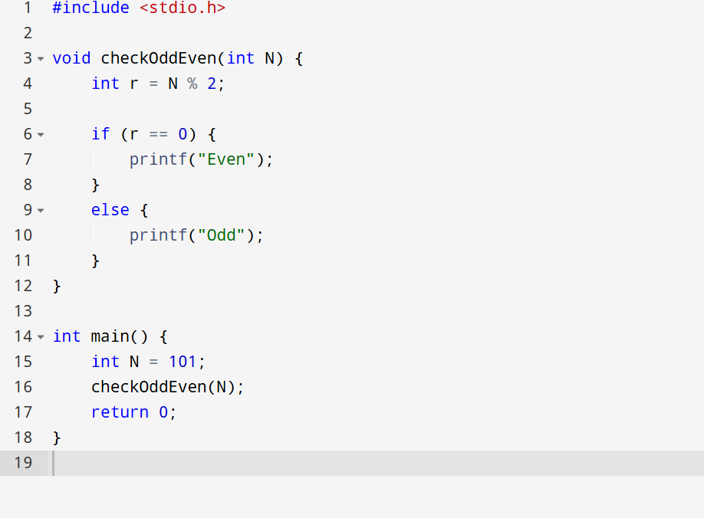

OUTPUT

Odd